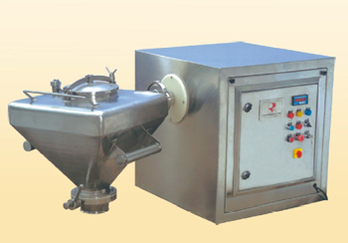

***Conta Blender***

For Mixing Solid with Solid

For Blending Granules with Lubricants

Capacity : 2.5 Ltrs. up to 1200 Ltrs.

Conta Blender Conta blenders are used mainly for blending of dry powders for capsule plant, for blending and homogenizing of dried granules for tablet production. Conta blender is latest cGMP concept with an emphasis on the dust free transfer of powders and granules at different stages from sizing /dispensing to compression / filling of tablets or capsules.The process involves collecting the sized granules in a container, wheeling it to the blender, engage the same with clamping system, lift and tumble for the prevalidated time in set number of rotation.

====================================================================

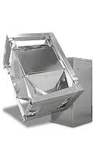

***IBC Blender***

speed to add high sheer to the **IBC** as it is tumbled by the **IBC**

Capacity : 2.5 Ltrs. up to 1200 Ltrs.

IBC Container blenders have long been established as the most efficient method of blending granules and powders in the pharmaceutical manufacturing process. Reduced loading and unloading times, reduced cleaning time of both machinery and room, improved containment and batch integrity have established IBC blending as the pharmaceutical industry’s technology of choice.

=====================================================================

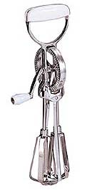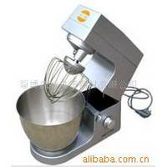

***Egg Shell Blender***

Capacity: 500 to 5000 Ltrs.

High quality milk/ egg mixer/ blender, perfect supply the material for cake, milk, tea, coffee, etc, 5L and 7L.

========================================================================

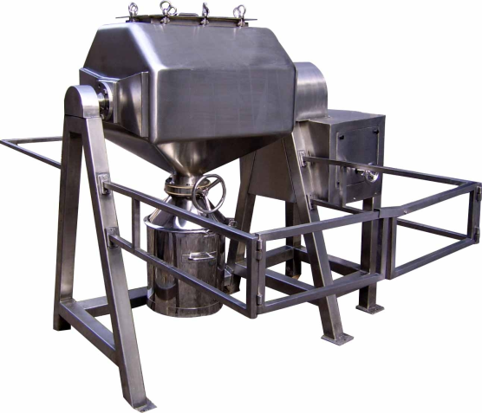

***Octagonal Blender***

The **OCTAGONAL BLENDER** is an efficient and versatile blending machine for mixing and lubrication process of dry granules homogeneously.

The Octagonal Blender complements our wide range of Powder Blending Equipment, ideal for dedicated production campaigns. Units designed for bin charging and discharging systems allowing dust free operations.

Specially designed and constructed body allows for slow tumbling, leading to shorter mixing periods vis a vis Double Cone or Cube Blenders without degrading the powder structure. Models range from 25 Ltrs to 5,000 Ltrs in various materials of construction.

The special shape of these units allow for reduced motor sizes and resulting low running costs as compared with other units. More than 100 units are in operation in industries such as Food, Dairy, Pharmaceutical, Pesticides, Dyes, Drugs, and Chemical.

=================================================================================

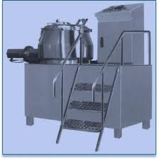

***R.M.G.***

High detail RMG (Rail Mounted Gantry Crane) container transport. As used in container ports and warehouses worldwide. Part of a range of consistently authored related industrial vehicles. See our other models in this range.

===================================================================================

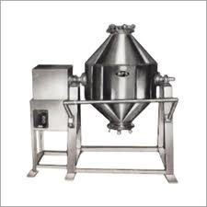

***Double Cone Blender***

The Double Cone Blender is an efficient and versatile machine for mixing dry powder and granules homogeneously.

Capacity : 10 kg., 25 kgs., 50 kgs., 100 kgs., 200 kgs., 300 kgs., 500 kgs.

There is a Powder Blender to suit every application. Intended for use within the pharmaceutical industry, the same standards are applied across all industries which employ a Double Cone Blender, offering purchasers an advanced quality of finish at a very economic price.

The Bectochem Cone Blender and Double Cone Blender are the optimum equipment for homogeneous blending of powders for any industry be it chemical food or pharmaceutical.The range of capacities available, rotational speeds, and materials of construction means there is a Bectochem Powder Blender to suit every application.

===================================================================================

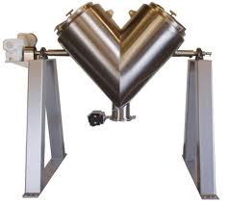

***V- Blender***

Tumble mixers, such as the V-blender, are simple in concept and commonly used in industrial processes.

 KMMC 10 Cu Ft Twin Shell / **V**-**blender** Mixers. Stock# 4679; **Capacity** 10 Cu Ft

===================================================================================

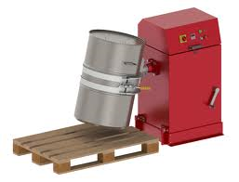

***Drum Blender***

Industrial drum mixers are ones where the drum is rotating and the blades are stationary. Its design of the blades is given such that the powders are mixed homogeneously.

25 kg to 500 Kgs batch capacity.

=================================================================================

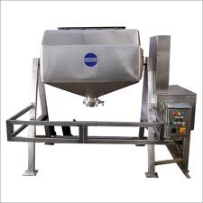

***Octagonal Blender***

The **OCTAGONAL BLENDER** is an efficient and versatile blending machine for mixing and lubrication process of dry granules homogeneously.

=====================================================================================

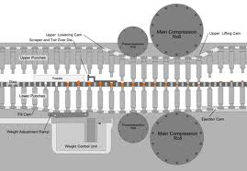

***Tablet Press***

A **tablet press** is a mechanical device that compresses [powder](http://en.wikipedia.org/wiki/Powder_%28substance%29) into [tablets](http://en.wikipedia.org/wiki/Tablet) of uniform size and weight. A press can be used to manufacture tablets of a wide variety of materials, including [pharmaceuticals](http://en.wikipedia.org/wiki/Pharmaceuticals), illicit drugs such as [MDMA](http://en.wikipedia.org/wiki/MDMA), cleaning products, and [cosmetics](http://en.wikipedia.org/wiki/Cosmetics).

=====================================================================================

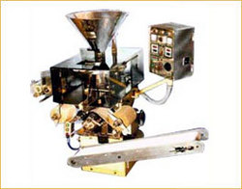

***Strip Packing m/c***

The unit consists of drive 0.5HP/1440 RPM/3PH/415V/50CS AC Motor coupled to worm reducer variable pitch pulley arrangement and multipin clutch. Drive mechanism housed in MS fabricated body with necessary opening for inspection and maintenance. One set of sealing rollers Max. 140 mm sealing width with back gear and pin ring. Horizontal scissors action cutter is provided to cut the strip horizontally by cutting gear assembly to obtain desired cut length of strips.

Capacity Tab. Per Min. : 600-800

=====================================================================================

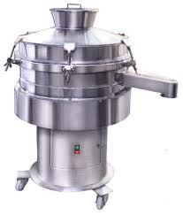

***Vibro Sifter***

**Vibro** separators are circular gyratory screens used to separate solids from solids and liquid from solid. Vibro Sifter consists of Specially Designed Motor mounted vertically at the center of the base plate of the Screen. The Screen is in between feeding hopper and bowl. The material is fed on to the centre of top screen. The undersize material passes rapidly through the screen during its travel to the periphery. The over size material get continuously discharged through a tangential outlet. This is achieved by specially designed Vibratory Motor along with eccentric Top and Bottom Weights.

==================================================================================

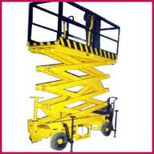

***Hyd. / Pneumatic Mobile Lift***

This machine with a forced balance device.The two side are rising and descending synchronized....

Capacity 0.3 T to 6 T. Maximum **lift** 7.5 meters.

===============================================================================

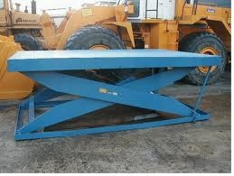

***Hyd. Lifting & Tilting Device for F.B.D. Bowl Range – 30 Kgs to 500 Kgs.***

We at LIFTWELL ENGINEERS manufacture and supply excellent quality HYD. LIFTING TABLE HEAVY DUTY.

Lifting capacity: 3,000kg Lifting height: 2,200mm Min. height: 310mm Lifting time: 50-60s Power

=================================================================================

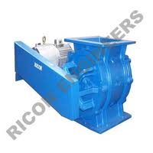

***Rotary Valve for controlled feeding of material ( Pneumatically Operated)***

With the assistance of our advanced technology, we have been offering quality range of rotary airlock feeder, valve. Our range of rotary airlock valves includes bottom discharge type, blow through type, side entry type, sanitary type, double barrel type and vertical type. Provided with heavy-duty outboard bearing and airlock sealing, these rotary airlock valves are widely used for material ranging from granules to super fine powders. Having direct drive or chain drive, these feeders are extensively used for material handling system and pneumatic conveying system.

===================================================================================

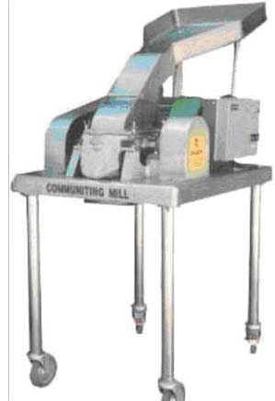

***Co – Mill***

We are one of the best pharmaceutical machinery manufacturers; Communitng Mill is our well established product.

=====================================================================================

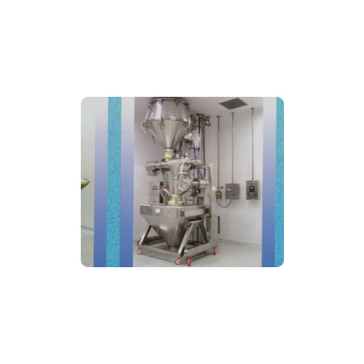

***Turbo Sifter Cum Multi mill***

Turbosifter cum Multimill machine is used for high speed sieving and milling simultaneously to achieve uniform properties. Sieving and milling process is achieved by means of passing the dry granules through Sifter and then passing through the Multimill. The time taken for the entire operation is less as compared to vibratory Sifter and Multimill individually. The process is less dusty and laborious.

==================================================================================

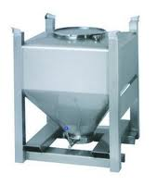

***S.S. Bin , S.S. IPC and Tablet Container , S.S. Blender Bin Range - 2.5 Ltrs to 2000 Ltrs.***

Bin (IPC) is a container made from SS 316 sheets having cylindrical Body and taper bottom. A lid is provided on top. The lid is big so that complete washing the IPC is easy. The Bin is seated on a detachable stand or fixed leg made of SS 304 pipe stand, having forelegs and each leg is fitted with heavy duty castor wheel of special design with ball bearing and SS side frame (2 nos. fixed and 2 Nos swiveling).

=====================================================================================

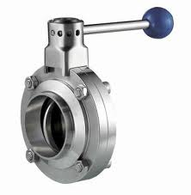 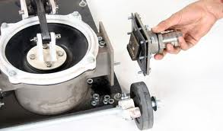

**S.S. Butterfly Valve *S.S. Soft Flap Valve***

***S.S. Butterfly Valve and S.S. Soft Flap Valve for Tablet Container Range – Dia. – 75 mm. to 400 mm.***

The sanitary butterfly valve is designed to handle powders and granules and can be installed on bins or vessels, containers and pipes

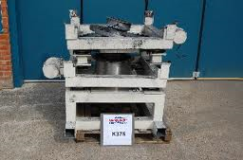

***Bin Docking system***

Tote Bin Discharge Frame With Docking Mouth And Vibration Unit. Painted Mild Steel Frame. Suitable For Container With 1M Square Footprint.

*========================================================================*

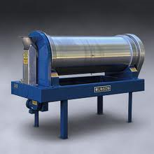

***Y-Chute With dust free connection***

he Munson Rotary Continuous Mixer provides gentle, 100 percent uniform, dust-free blending at rates from 25 to 5000 cubic feet per hour—inexpensively and in minimal floor space.

=====================================================================================

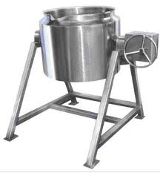

***Starch Paste Mfg. Vessel***

Starch Paste Kettle will be made out of S.S. 304 Rectangular Pipes and will be an independent resting type frame work where no foundation will be required. The Kettle will be a hemispherical type bowl with either steam / Oil / Water heating Jacket will be provided. The Kettle will be manufactured from 2.5 mm thick S.S. 304 Sheet and The Jacket will be of 2.5 mm Mild Steel (In case of steam Jacket the thickness will be 4 mm) There will be oil / water heated fitted at the back bottom side of the Kettle. The Kettle Will be having a worm type arrangement for tilting. A temperature controller & a temp Indicator will be provided for temp control & Indication. The Kettle will be Insulated with 50 Mm thick glass wool Insulation & Claded with 16 Swg S.S. 304 Sheet. Starch Paste Kettle will be buffed to 150 grit matt finishes externally and Internally the Kettle will be buffed to 220 grit mirror finish

=====================================================================================

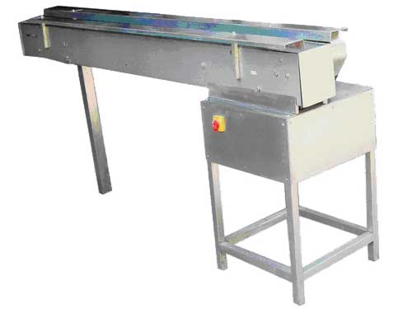

***Packing Belt Conveyor***

The packing conveyor belt is having stainless steel table top with moving endless sandwich belt in the center. Tabletop is fixed to the same structure made out of SS square pipe and supported on adjustable bolts. Tabletop is of 12 inches working space on both side of the conveyor belt for final visual inspection dn packing.

====================================================================================

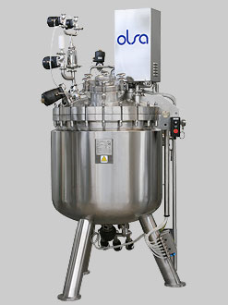

***Solution Preparation Vessel***

• Wide range of models from 25 to 12.000 lt capacity and  customized execution to meet the most particular requirements of end-users.

• cGMP & FDA compliant design, ASME/PED certification.

• A wide selection of agitators from sterile magnetic stirrer to powerful disperser-homogenizers  grant  top mixing performances with different products. High versatility and flexibility in design and manufacturing allow Olsa to offer a vessel for any product even the most unusual and difficult to produce.

• Wide choice of accessories and control instruments of qualified suppliers are installed in Olsa package.

• CIP and SIP integrated systems to grant the highest cleaning and sterility standards of the pharmaceutical  world.

• Manual or automatic operational functions controlled by PLC and dedicated validable software package.

====================================================================================

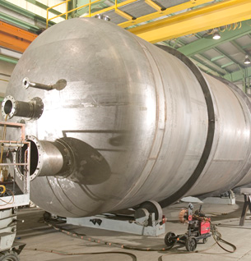

***Pressure Vessel***

We have designed and manufactured vessels in Alloy steels, SS 304, SS 316 and is capable of manufacturing in any material. We have supplied vessels upto 12 meters long and 6 meters in diameter, weighing upto 40 tons from design to fabrication.